What is agile project management?

For an introduction agile means fast. agile project management is a replacement for waterfall model which has its own benefit but in our current dynamic environment most of the company opt for agile methodology.

it is a process by which a team can manage a project by breaking it into several stages (planning, execution and evaluation ) and involving constant collaboration with customer and continuous improvement at its each complete iteration.

The Agile methodology start with clients describing their product the main objective here is to understand what the customer expect from the end product.

once that is done team decides the workflow of planning, development, testing and execution

here the main highlight is continuing collaboration that is stake holders are provided with a demo at each iteration which give them an over view of the product and they can do further evaluation and analytical work to see the success rate of the product before the entire product is built.

Agile Methodologies Frameworks

Popular frameworks are:

* Scrum
* Kanban

Kanban

it is a visual approach to project management here teams create a physical representations of all the tasks, mostly using sticky notes on whiteboards or even online tools are also used such as Jira. Tasks are moved through stages which are predetermined to track progress and identify common roadblocks.

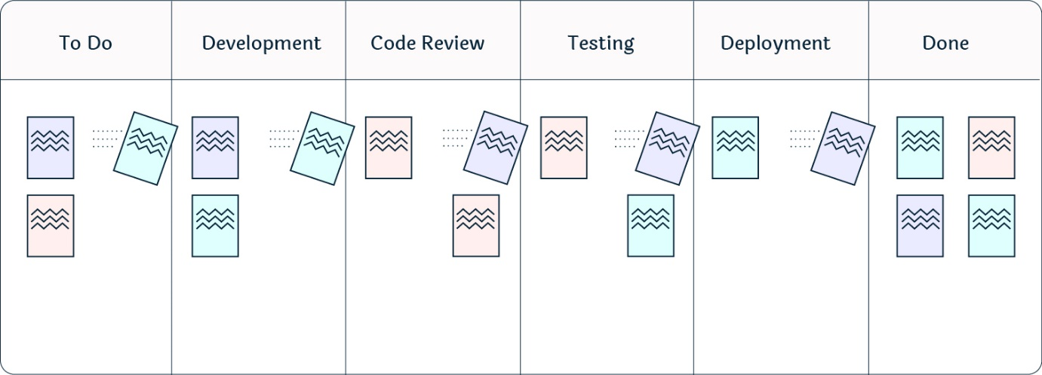

Image Credit : <https://getnave.com/>

Scrum

A project management methodology where a small team is led by a Master (scrum master) whose main job is to clear away all issues to completing work. Work is done in short cycles called as sprints, but the team meets daily to discuss their progress which is time bound.

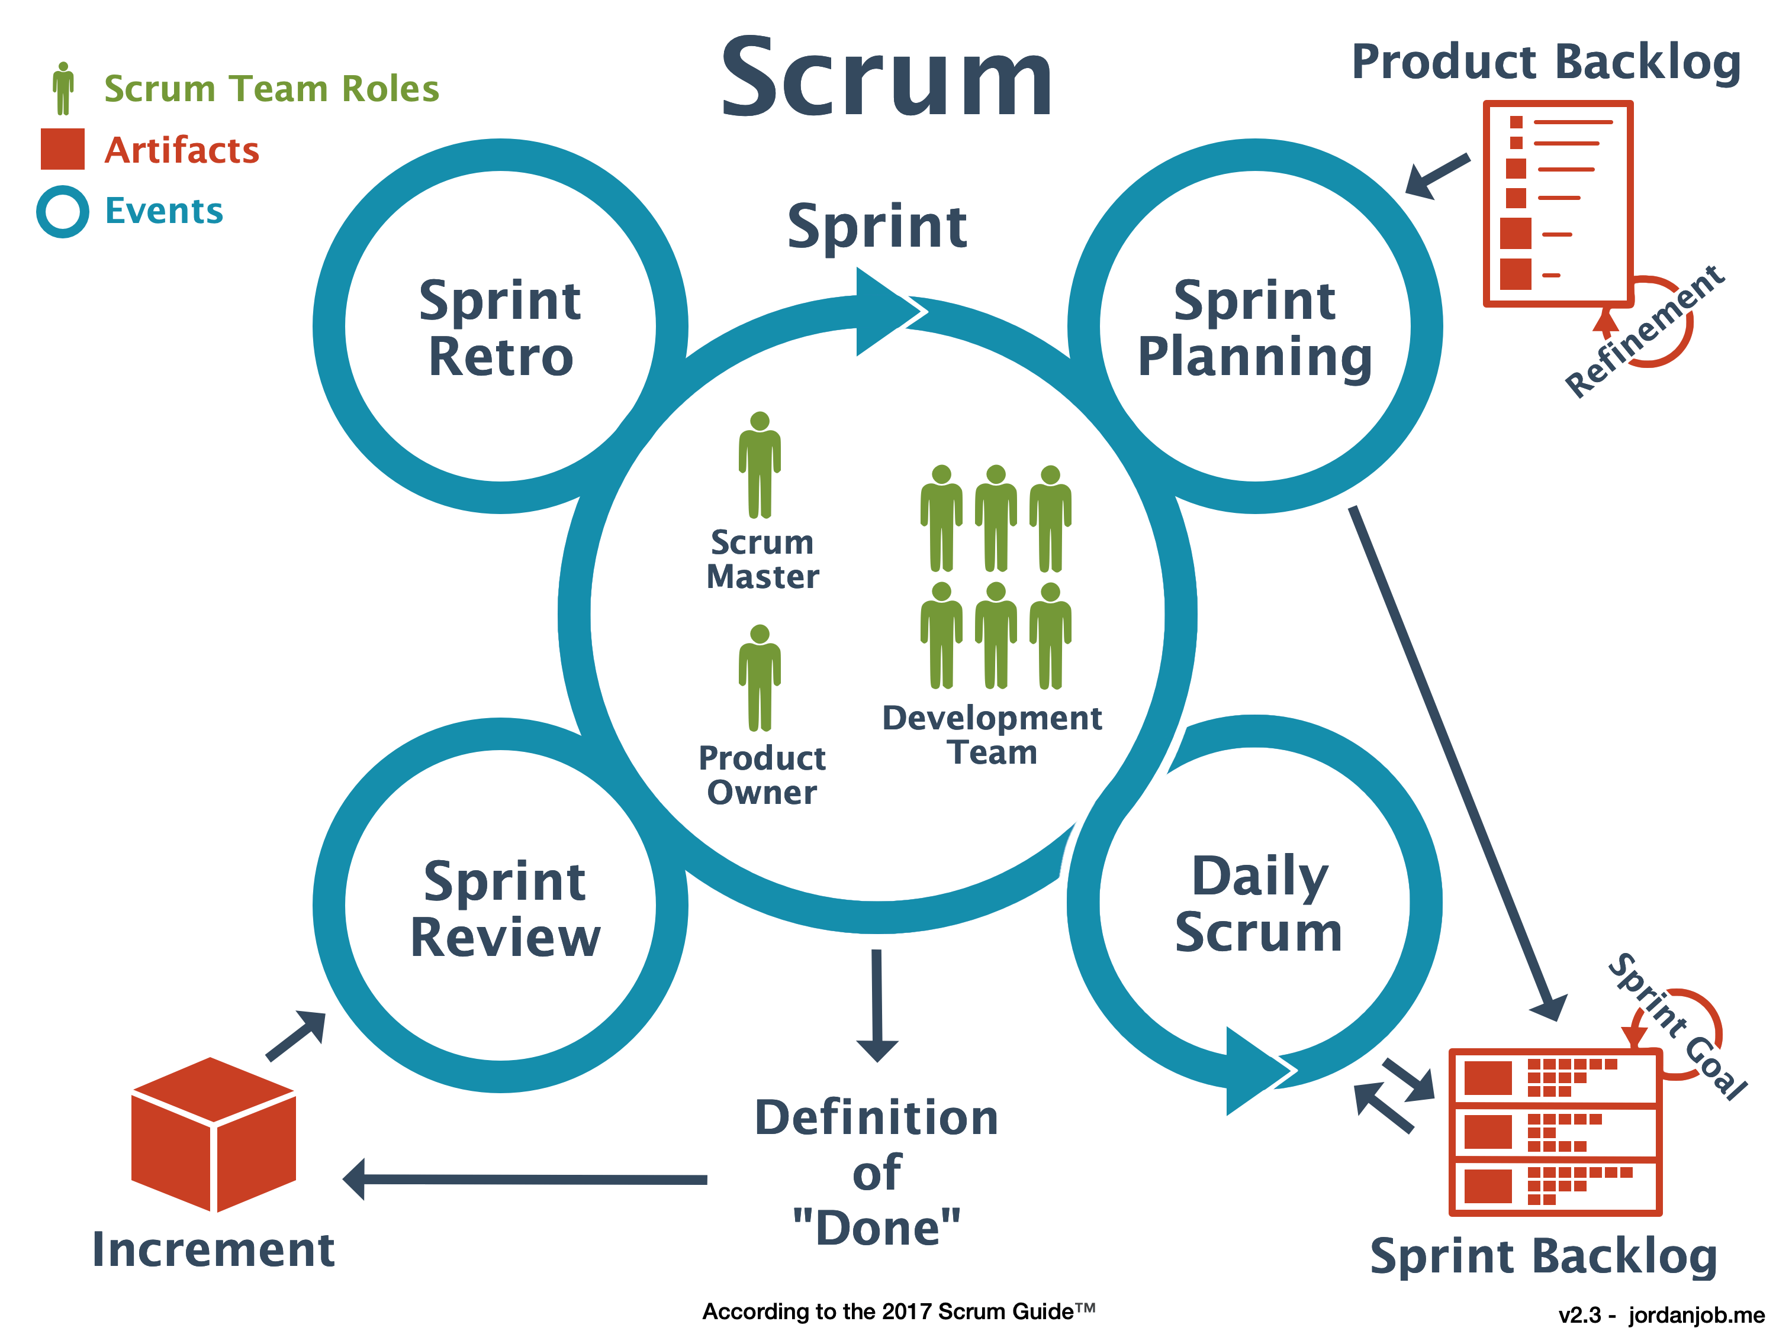

Image credit: <https://jordanjob.me/>